Date: 10 October 2022
Publication: I-News
Section: Opinion
URL: https://inews.co.uk/opinion/windrush-generation-father-passions-repay-writing-188769

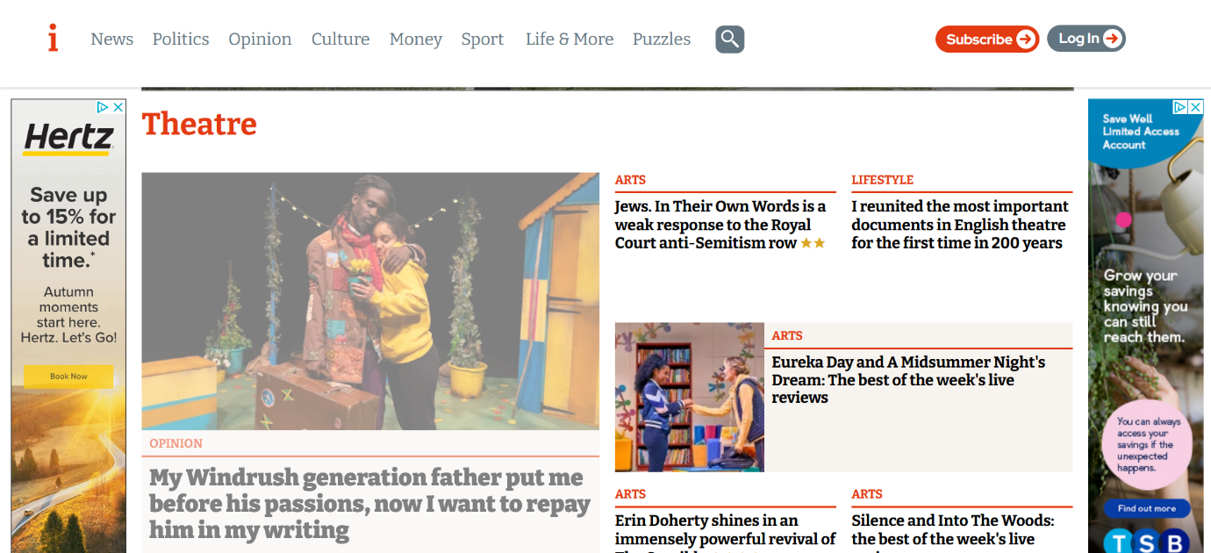

My Windrush generation father put me before his passions – now I want to repay him in my writing
It’s thanks to those foundations laid by my parents that at the age of 52, my first play for children is on a 26-date nationwide tour throughout Black History Month
October 10, 2022 12:46 pm

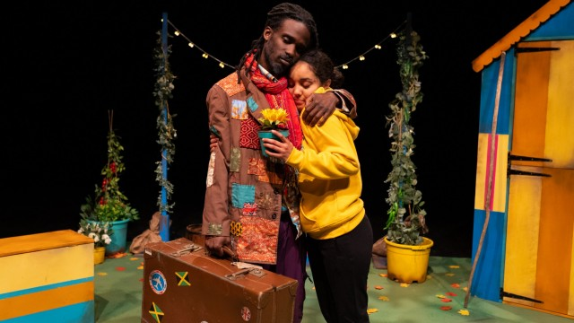Opening night of Elayne Ogbeta’s play, ‘Grandad Anansi’ (Photo: Lizzie Henshaw)
It’s no secret that when the Windrush generation came to the UK in search of a better life, employers and landlords openly discriminated against the very workers the government had turned to for help to rebuild a war-ravaged economy.
Many of the 71,000 women who made the journey were sought after to train as nurses, but given menial tasks and subjected to workplace bullying and discrimination. Almost half of the 90,000 Caribbean-born men who had settled in England and Wales by 1961 came from highly-skilled backgrounds, but were only able to find work in jobs considered “undesirable” by local people.
My father, Ashley, came to the UK from Jamaica in 1963: two years before the Race Relations Act outlawed racial discrimination in public places, and five years before the updated 1968 Act prohibited discrimination in employment and housing. He worked in factories and as a labourer – work that would provide a steady wage and a happy and secure home life for my brothers, sister and me in 1970s Preston. It was work that enabled my mother to stay at home, and gave us security, stability and family meals. My parents, and the thousands of other Caribbeans who came to the UK, did so with the strong belief that each generation lays the foundations for a better life for the next.
However, my dad was – is – an incredibly gifted storyteller and lover of poetry. He saved his creative talents for the evenings, when he would enthral us with his classic tales of the wily Anansi, part-human, part-spider. Cunning as they come, Anansi is able to outsmart the most powerful of foes. The stories, which originated as an oral tradition in West Africa, travelled to the Caribbean via enslaved people. I think the character Anansi’s enduring appeal is that he brings hope and represents the spirit of freedom, using his natural intelligence to fight back against dominant forces.
Even now at the age of almost 90, my dad continues to delight all nine of his grandchildren with his beautiful storytelling, preserving an important part of our heritage and growing strong bonds between the generations.
And it’s thanks to those foundations laid by my parents that at the age of 52, my first play for children is on a 26-date nationwide tour throughout Black History Month, which includes London’s Lyric Hammersmith.
The play – Grandad Anansi – is loosely based on the life experiences of my dad, and it’s just one of hundreds of stories and poems I’ve written since I was a child. I have a master’s degree in creative writing for children, so when I saw myself described as an “emerging writer” in the press material for the play it made me chuckle.
But until Grandad Anansi was picked up by Manchester children’s theatre company Z-arts earlier this year (and developed in partnership with Tower Hamlet’s-based Half Moon Theatre), the description I was much more familiar with was simply “Mum” – and I wouldn’t have it any other way.
My children are Naomi Metzger, the 10-times British triple jump champion and Commonwealth Games bronze medallist, and Swansea City defender Nathanael Ogbeta. Even before their sporting prowess became apparent, my husband Mathias and I had made the conscious decision to make them the focus of our family – just as my parents had done before me.
Mathias, a software development manager of Nigerian heritage, took work close to home so he could be there to help out practically. I decided to set aside my ambition to be a writer, working part-time after Naomi was born and giving up work completely when Nathanael came along.
Nathanael’s talents were spotted when he was just five-years-old. By 10, he had been signed by Manchester City. Naomi won all her races at school, so we suggested she take part in after-school athletics clubs. She ran with Trafford Athletic Club before discovering a talent for triple jump and within a year she was competing nationally.
The years of training were intense for both of them, and every day of the week, Mathias and I juggled the journeys to football training grounds and athletics clubs between us.
While my career is beginning to take off now that I’m well into middle age, it’s unlikely Naomi or Nathanael would have become professional athletes if I’d chosen to put myself first – they both had highly gifted friends who had to give up training because of the intense demands it placed on their families.
Mathias and I both feel incredibly lucky to have been able to focus on our children and play such an active role in their athletic development. I am immensely grateful for the opportunity to do that. What I did was my own personal choice, not at all a sacrifice, as some (well-meaning) people have labelled my decision.
As the daughter of a Windrush migrant, I’m acutely aware that for many, sacrifice meant leaving children behind with relatives – the so-called “barrel children” – whilst trying to establish a new life on a strange and inhospitable island, in cramped and hostile conditions.
The Black Caribbean community – and the wider Black community more generally – is strong. Family wholeness, education and welfare of children are incredibly important to us, and we believe and promote that each generation will be better than the last. So, while I appreciate the platitudes, I can’t accept that my decision to postpone my career was a sacrifice.
While Naomi and Nathanael were training, I continued to write in my spare time – I gained my master’s degree by studying two evenings each week. When they were older and the demands on my time became less, I taught English as a foreign language in a local college, and I never stopped writing for fun. At the back of my mind, I always knew that my time would come.
And with two happy, successful and independent children, that time is now.
As well as Grandad Anansi, I have a children’s picture book in development, and hundreds of poems and stories ready to share with the world. My dad is thrilled to be the subject of my first play, and continues to inspire me with his stories. And my children are supportive, proud and happy to see me finally achieve my lifelong ambition, whilst they both continue to thrive at theirs.
Elayne Ogbeta is a children’s writer. Grandad Anansi is touring the UK throughout Black History Month. For more information click here

