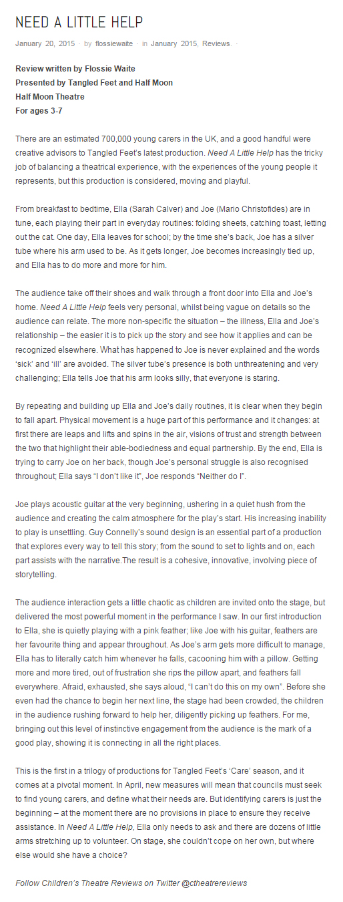
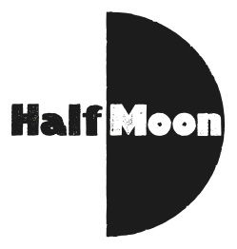
Date: 20 January 2015
Publication: childrenstheatrereviews.com
Section: Reviews
URL: http://childrenstheatrereviews.com/2015/01/20/need-a-little-help/

