Date: 1 April 2017
Publication: Docklands and East London Advertiser
Section: Education
URL: http://www.eastlondonadvertiser.co.uk/news/education/over-the-moon-schoolgirl-emily-kennedy-gets-her-half-moon-theatre-review-in-print-1-4957180

‘Over the moon’ schoolgirl Emily Kennedy gets her Half Moon theatre review in print
PUBLISHED: 07:00 01 April 2017 | UPDATED: 16:18 05 April 2017
Mike Brooke
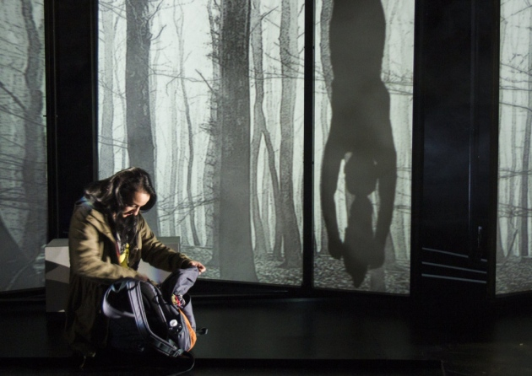
Half Moon's production of 'Her' [pictures: Ed Sunman]

Schoolgirl Emily Medina Kennedy dreams of being a theatre critic one day—she’s busy practicing the art of reviewing with visits to east London’s famous Half Moon education theatre.
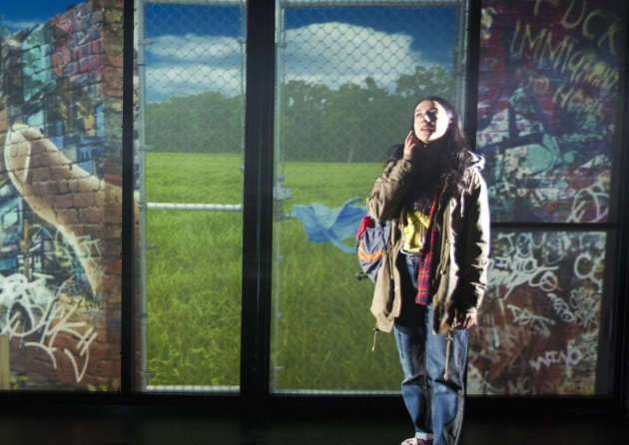
Shala Nyx in the one-woman play 'Her'
The 14-year-old from Poplar went to the Limehouse theatre to see Her, a one-woman play by writer-director Dominic Hingorani with Shala Nyx on stage in conversation with her pre-recorded self.
“I’ve always loved going to the theatre since I was a toddler,” Emily tells the East London Advertiser. “I saw the programme at the Half Moon for the new season of plays and thought I’d ‘have a go’ at writing a review.”
We’re happy to oblige—here’s what Emily writes about Her:
A typical London teenage girl arrives home to see that her house is gone, her family is missing and she has nowhere to go—she is a victim of war.
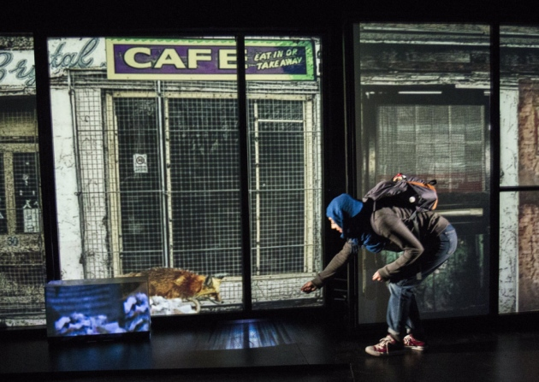
Writer-director Dominic Hingorani's play 'Her' set in a war zone
“Shala Nyx goes through the different personas of women trapped in conflict, portrayed using digital projections, film and live action.
Blurring the line between ‘real’ and ‘virtual’, the production contrasted how in the past, ‘virtual’ conflict appeared to us. However, as war approaches, Western society finds itself closer to chaos than we had expected.
Imaginatively, the Brolly team projected pre-recorded footage onto a moveable set, creating a visual intensity synchronised with the thought-provoking performance.
The play tackled issues such as gender discrimination, religious hatred, terrorism and immigration, particularly targeting young people.
Brolly Productions prompted the audience at an after show Q&A to discuss the play’s issues and handed out contact details for organisations such as Amnesty International and War Child. —Emily Kennedy.
The play with Shala Nyx at the Half Moon in White Horse Road, Limehouse, has since gone on tour, but the theatre is negotiating for its return to east London next year.

