Date: 6 February 2017
Publication: A Younger Theatre
Section: Review
URL: http://www.ayoungertheatre.com/review-her-half-moon-theatre/

Review: her, Half Moon Theatre
By Dan Rubins on February 6, 2017 in Theatre
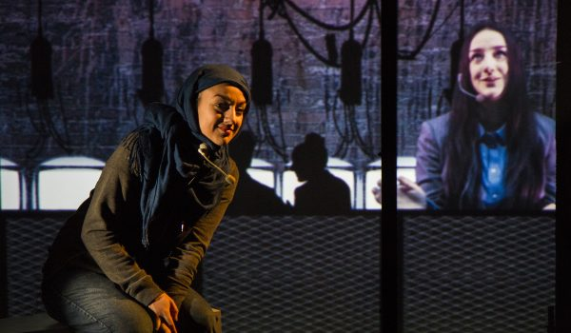
The young refugee turns to the audience, beseeching someone to help her, begging for someone to listen. When no one speaks on her behalf, she follows the bus driver, whose help she so desperately needs, into a shop, where, we sense through grainy audio and video projections, he rapes her. It is a horrifying moment, one that implicates the audience, her silent bystanders, in the brutal assault. One problem with this scene, as with so much of her, written and directed by Brolly Productions’ co-artistic director Dominic Hingorani, is that we know almost nothing at all about this woman. At the same time that her asks us to empathize as we confront the brutal tales of five different women (each played by the talented and chameleon-like Shala Nyx) caught up in violent conflict, Hingorani’s text denies us the opportunity to get to know these women with much more specificity or clarity than we know the real-world victims we hear about on the news. Nyx plays all five women in order to stress the universality of their plights, but, ironically, keeping these women nameless and unbound from history or geography makes it harder to connect with them as fully rendered human beings.
The other problem in that shocking scene of violence is that the implicated audience consists almost entirely of teenagers: her is co-produced by the young people’s company Half Moon Theatre. It’s not that London’s youth cannot handle the seriousness of war. In fact, at a Q & A following the first performance, the secondary school students in attendance engaged impressively with the material. However, Hingorani has said that he wants audiences to confront the question, “What are we going to do about this?” her presents a set of scenarios so grim, so hopeless, and so abstract, that it seems unlikely that, without a post-play debriefing, students will walk away from the theatre entirely sure what “this” actually is. Hingorani’s efforts to educate young people about the horrific perils facing women in Syria and other war-torn nations end up engulfed by the play’s confusing narrative and the relentless violence which comes at the expense of developing character. (Hingorani occasionally aims for an absurdist sci-fi texture but more often veers towards dystopian incoherence as when one of the women inexplicably winds up answering soldiers’ Skype calls in the basement of a café owned by a French man with electric octopus tentacles.)
her’s greatest asset is Rachana Jadhav, the designer/illustrator and Brolly Productions’ other co-artistic director, whose projections provide the play’s sense of momentum. Jadhav’s animations (on to which pre-recorded videos of Nyx have been superimposed using green-screen technology) are often both beautiful and effectively disturbing, skillfully bringing the graphic novel genre to life. The interactions between the projections and Nyx’s live performance work particularly well. An early moment in which Nyx shares her crisps with an unseen figure whose hand descends from the top of one of the projection panels seemingly to reach into the onstage bag is enchanting. Nyx’s shape-shifting performances on video – she plays a number of pre-recorded parts, male and female, in addition to her five onstage characters – similarly demand appreciation. Once that sickening rape scene has taken place, though, it seems inappropriate to take pleasure in either Jadhav’s achievements or Nyx’s virtuosity: her offers feats of technology and performance that deserve our admiration, even wonder, but it simultaneously forbids us from experiencing anything other than horror at, and revulsion from, the actions portrayed onstage.
The world depicted in her is entirely without redemption or hope. It’s not that the people who want to help are rendered powerless; they simply don’t seem to exist at all. Accompanying that bleakness is the troubling suggestion that victims of violence will ultimately resort to violence themselves: to secure her place on the overflowing bus, the rape victim caustically accuses a passenger in a hijab of being a terrorist. In the final scene, a different young woman wandering in a forest slashes open the shadowy body of a mother hanging upside-down from a tree, and blood drips across the video panels. (Even those adults who most vehemently oppose trigger warnings should hopefully agree that the 13+ audience advisory on the Half Moon Theatre website, with no discussion of the play’s sexual violence, strong language, and stomach-turning descriptions of war crimes against infants, is rather inadequate.) During the Q & A panel, Hingorani repeatedly stressed that her demonstrates the impossible choices that young women in conflict situations are forced to make. Even if the violent acts emerge from desperation, for a play with an activist mission, is it really productive to show these characters mimicking the senseless cruelties of their assailants?
Nonetheless, Half Moon Theatre’s investment in arts education in East London, and the partnership between this production and organizations like Amnesty International UK, War Child, and the Tony Blair Faith Foundation deserve recognition. While her may not yet be meaningful in the ways it hopes to be, raising awareness of critical global issues through the engagement of young people in the arts has never been more important.
her is playing at the Half Moon Theatre until February 7.
Photo: Ed Sunman

