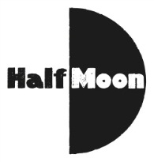
Date: 5 February 2017
Publication: Children’s Theatre Reviews
Section: Review
URL: https://childrenstheatrereviews.com/2017/02/05/her/

HER
February 5, 2017 · by flossiewaite · in February 2017, Reviews. ·
Reviewed by Flossie Waite
Brolly Productions & Half Moon present her
Reviewed at Half Moon Theatre
Playing at Half Moon until 7th Feb; touring until 13th Feb
For ages 13+
“You know they fuck babies, don’t they? Not one, loads. And they film it. Now, how can that be part of war?” her dares to be explicit and graphic, confronting the exploitation, sexual violence and grim choices girls and women encounter in conflict. The inclusion of such content in a production aimed at teenagers is shocking (in the sense that it is unusual), but the content itself is not. The play introduces five different ‘girls’ (all played by one performer, the brilliant Shala Nyx) and their displacement due to war, but these quick glimpses only allow us to get about as far into their lives as the news does. The potential impact is further diluted by the design: her is concept-heavy, a multimedia experience that integrates animation, film and live action, offering abstract backdrops that jar with the play’s intention to centre female reality. her gives us a headline, when we need the Long Read.

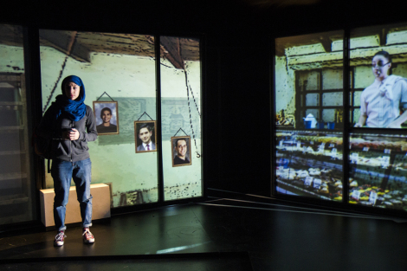
her, a brolly and Half Moon co-production, moves so quickly there’s no chance to make a connection with the characters. They function as examples, in sliced scenes that are joined not by narrative but their affiliation with the theme of girls in conflict: instances of what’s happening somewhere else, rather than rounded, realistic people. Where they are is never clear, and while this is meant to suggest that all of the action could just as easily be happening here, the effect is that it all becomes blurred into one big conflict, generalized and vague and as far away as ever.

Map of Me brought the refugee experience close-up (it was a Papertale production in association with Apples & Snakes and was presented by Half Moon in 2015.) Map of Me was a spoken word performance that took the numbers we are used to hearing and struggle to imagine (x number of asylum applications, x number of deaths in the Mediterranean, x number of refugees), and scaled them down to one – a girl. In contrast with her, the deeply personal and emotionally powerful account included the detail and nuance that these stories deserve, and brought a level of humanity that was hard to ignore. brolly themselves created a production that was all the more hard-hitting for exploring a single story: Guantanamo Boy. Performed back in 2013, this followed Khalid from his comfortable life in Rochdale to his imprisonment in the detention camp. The performers’ physicality and the realistic rhythm of conversation were recognizable, bringing home an experience that is otherwise as distant and inaccessible as moving to Mars, and making us feel that Khalid’s friends and family could be ours, and Khalid could be us.

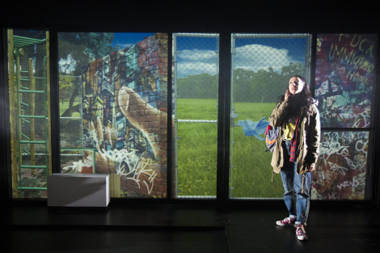
her, on the other hand, is a well-meaning but misguided vehicle led by abstract concepts that required more thought. The busy, technology-driven set intends to marry the ‘visual intensity of the graphic novel’ with intense theatricality, but it’s easy to get caught up in trying to decipher the illustrations, in noticing when the interaction between live performance and pre-recorded film doesn’t quite match, in wondering why the creative team have decided to place further distance between the girls’ experiences and the audience by placing them in ‘made up worlds’. To have the authority or the authenticity of a piece like Map of Me, should the creative team have empowered girls to tell their own stories or done more to include their voices? Messy, incomplete answers to these questions undermine and detract from the material. Superficial rather than hard-hitting, more abstract than gritty, her feels like a hasty sweep of current affairs, akin to a scroll through Twitter or a glance at the news. The snippets it presents fail to do justice to the richly harrowing, hugely important stories of its real-life subjects – motivated by a well-justified sense that female experience is lacking on stage, her struggles to convince in its attempt to put this right.

Children’s Theatre Reviews exists to help plug the gap in criticism and writing about theatre for young audiences. It is run entirely voluntarily, and needs support to continue covering and supporting the sector. For more information and to help give children’s theatre the voice it deserves, please visit our Patreon page.

