Date: 3 February 2017
Publication: Sardines Magazine
Section: Reviews
URL: http://www.sardinesmagazine.co.uk/reviews/review.php?REVIEW-West%20End%20&%20Fringe-her&reviewsID=2740

her
Written and directed by Dominic Hingorani. Produced by Brolly Productions and Half Moon.
Society/company: West End & Fringe (directory)
Performance date: 03 Feb 2017
Venue: Half Moon Young People’s Theatre. 43 White Horse Road, London E1 0ND
Reviewer/s: Susan Elkin (Sardines review)

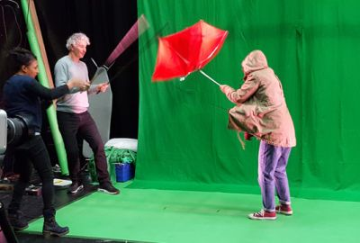
'her' rehearsal image
This piece presents the experience of young women from a wide range of perspectives with the very talented Shala Nyx playing all the roles. Sometimes she’s a London teenager. Then she variously becomes an abused middle Eastern refugee, a soldier, a Midlands young mum and much more. Sometimes she is in conversation with a second character she is playing via Ed Sunman’s digital projection. Her performance is outstanding. When she disappears – very reluctantly – into a room with a man who wants sex in return for a bus ticket the Muslim girl next to me flinched several times. The sound effects made it understatedly graphic.
The imaginative lighting, projection, animation and screen set – and the way the action segues in and out of filmic devices – is impressive too. And I have rarely seen a piece so full of issues. Members of the – predominantly Muslim – girls’ school party, alongside whom I saw it were each given lists of charities such as Amnesty International and LBTH Violence against Women and Girls at the end. They were also invited to attend free workshops at Half Moon the following weekend.
It’s a very worthwhile attempt to create a thought provoking hour from real life stories – I have no doubt whatever that every cameo is based on or inspired by genuine testimony. War, as one of the Half Moon staff told the audience is the Q&A which followed the performance, is universal and always current.
The problem with it is that it doesn’t make particularly good theatre. It’s very bitty and the narrative is confusing. Some of the girls sitting near me were quite restive because it wasn’t fully engaging their attention.

